- Write a java program to check whether the given number is odd or even.
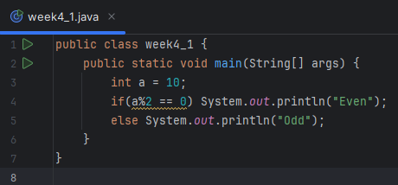
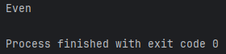
- Write a java program to find the largest number among the three numbers.
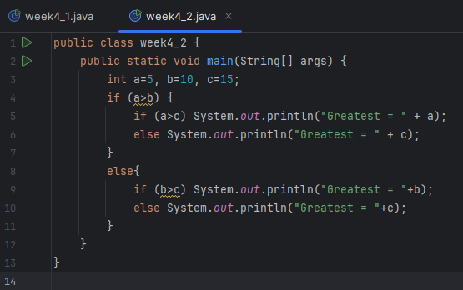
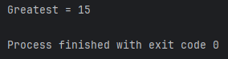
- Write a Java program that takes a number as input and prints its multiplication table upto 10.
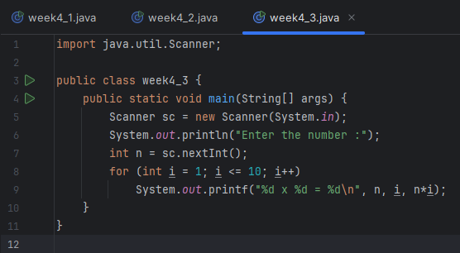
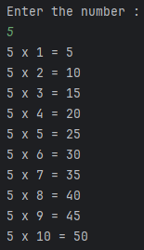
- Write a Java program to calculate the sum of following series:
1 + 2 + 3 + 4 + .......... + N.
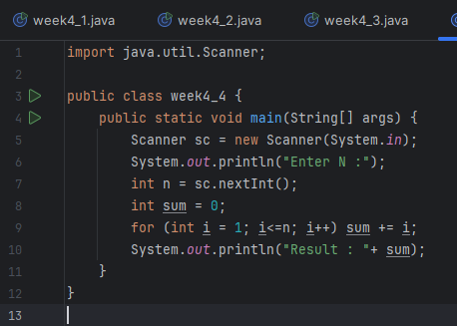
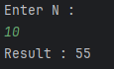
- Write a Java program to take a number, divide it by 2 and print the result until the number becomes less than 10.
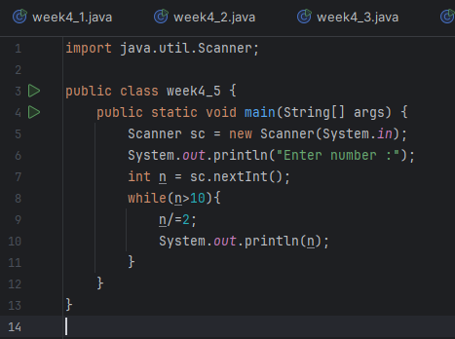
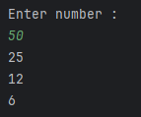
- Write a Java program to check whether a given character is a vowel or consonant.
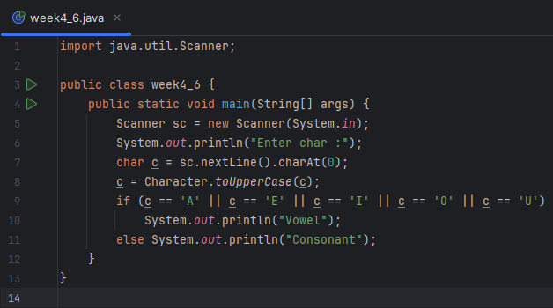
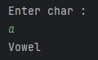
- Write a Java program to find the smallest number among four given numbers.
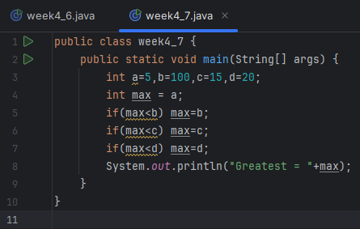
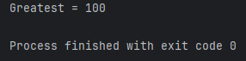
- Write a Java program to calculate the sum of all even numbers from 1 up to a given number N.
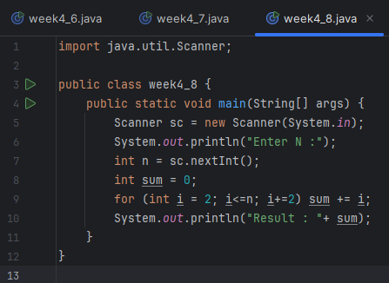
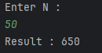
- Write a Java program to check whether a given year is a leap year or not.
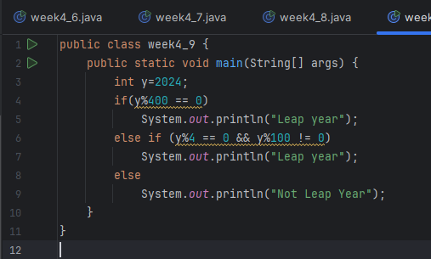
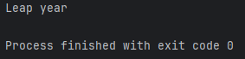
- Write a Java program that takes a number as input and prints all its factors.
